How to set up Eclipse to compile RepRapFirmware

1. Install Arduino IDE and Eclipse (Luna at the time of writing)

2. Get a copy of the latest RepRapFirmware files and put them in a directory of
your choice.

3. Copy „RepRapFirmware.cpp“ and „RepRapFirmware.h“ to a
temporary location, you will need them later on.

4. Open Eclipse and create a new workspace

5. Install the Arduino Eclipse Plugin

a) Go to „Help → Install New Software“

b) Add a new repository called „Arduino Eclipse Plugin“ with this URL:
http://www.baeyens.it/eclipse/V2

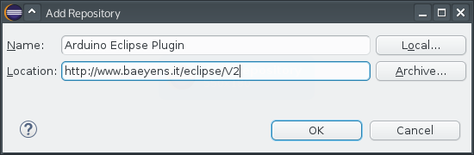
c) Untick „Group Items“ and check „Arduino eclipse extensions“ in the list:
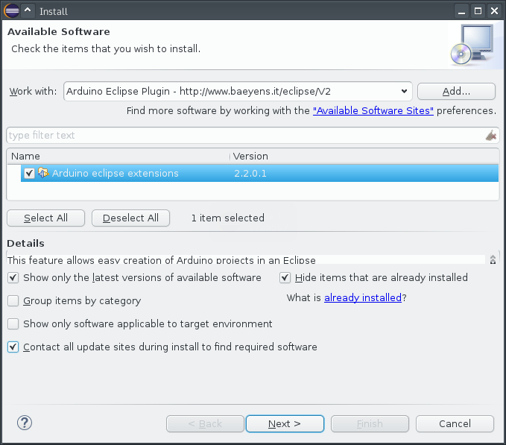
d) Finish the wizard and confirm the following warning message

e) Restart Eclipse

6. Set up Arduino Eclipse plugin

a) Go to „Window → Preferences → Arduino“

b) Select your Arduino IDE path. On Linux this directory is usually „/usr/share/arduino“ and on Windows „C:\Arduino1.6.1\“.

c) Set „Private Library path“ to the „Libraries“ directory in your
local „RepRapFirmware“ folder

d) Set „Private hardware path“ to the „Hardware“ directory in your local
„RepRapFirmware“ folder:
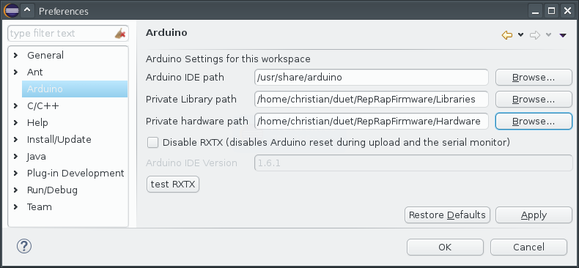
e) Save these settings

7. Create a new Arduino sketch:

a) Go to „File → New → Project“ and select „Arduino → New Arduino
sketch“

b) Call it „RepRapFirmware“ and set the location to the directory you
created earlier

c) For „Boards.txt“ select the new boards.txt file from your source
directory and choose „RepRap Duet Platform“. Optionally set your
upload port to „/dev/ttyACM0“ (if you're using Linux):
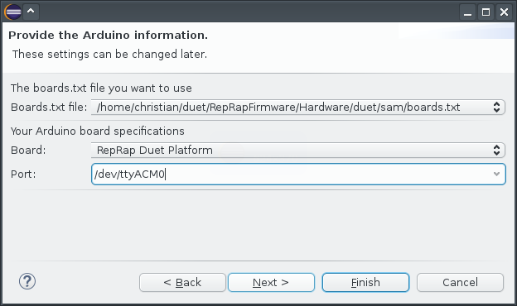
d) Check your source code directory for the following files or directories:
- .cproject
- .project
- .settings
- arduino
If any of them is present, it's a good idea to delete them before you
continue

e) Click „Finish“

8. Overwrite „RepRapFirmware.cpp“ and „RepRapFirmware.h“ with the two files
that you backed up earlier

9. Import the required extra libraries

a) Right click on „RepRapFirmware“ in the Project Explorer

b) Go to „Import... → Arduino → Import Arduino libraries in the current
project“

c) Select all personal libraries and click on „Finish“:
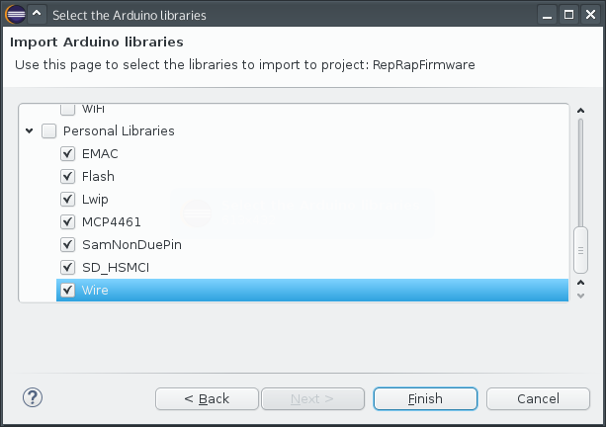
10. In the Project Explorer, right click on „Hardware“, go to „Resource
Configuration → Exclude from build...“, click on „Select All“ and press „OK“

11. In the Arduino toolbar, click on „Verify“ to build the firmware:

